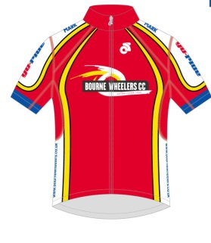
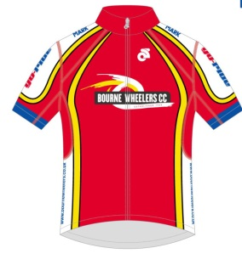
The Bourne Wheelers Cicle Classic Sportive

Saturday 31st August 2019

Rider Information and Safety

HQ Venue- Bourne Academy- Edinburgh Crescent, Bourne. Lincolnshire. PE10 9DT

Contact: Chris Kettle- chrisjkettle1971@hotmail.co.uk

Contents

Introduction…………………………………………………………………………………

Essential Information……………………………………………………………………...

Getting There…………………………………………………………………………

Parking and HQ……………………………………………………………………....

Medical Support………………………………………………………………………

Toilets………………………………………………………………………………….

Do’s & Don’ts’s……………………………………………………………………….

Pre Ride…………………………………………………………………………………….

Registration……………………………………………………………………………

The Start……………………………………………………………………………….

Pre Ride Briefing……………………………………………………………………..

Before You Ride……………………………………………………………………...

On Route…………………………………………………………………………………….

Signage………………………………………………………………………………...

The Hazards…………………………………………………………………………..

The Routes…………………………………………………………………………….

Post Ride……………………………………………………………………………………

Your Results………………………………………………………………………......

Refreshments…………………………………………………………………………

In the Event of an Incident or Problem……………………………………………………

Getting Lost…………………………………………………………………………...

Mechanical…………………………………………………………………………….

Accident or Medical………………………………………………………………….

Reporting and Incident Guide………………………………………………………

Event Team Contact……………………………………………………………………….

Introduction

Thank you for entering the Bourne Wheelers Sportive!

This is the 8th running of this event, which, in the past, has been a successful and enjoyable event, with many riders returning each year. This year it will form part of the Bourne Cicle Classic Cycle Festival.

This year, again, the start venue will be Bourne Academy. Details of getting there can be found below. The finish, this year, will be on West Street in the town centre, under the same finish gantry as the Cicle Classic road races.

The routes remain generally the same this year, with the addition of riding through Grimsthorpe Park and swinging around the outskirts of Bourne to finish along West Road. Links to Strava can be found on the Bourne Wheelers website- www.bournewheelers.co.uk. Event arrows will be at all turns on route, if there is no Arrow, stay on the road you are on.

There will be two feed stations, one at Buckminster for all routes and one at Woolsthorpe by Belvior for the long route, and cake and hot drinks at the finish.

WE ENCOURAGE RIDERS TO BRING ENOUGH FOOD AND DRINK FOR THEIR RIDE.

This year we have Neil Exton- All Geared Up, who will be our rolling Mechanic/Broom Waggon.

Good Luck, Ride Safe, and see you at the event.
Chris Kettle

Essential Information

Getting There

The Event parking HQ and Start is The Bourne Academy, Edinburgh Crescent, Bourne, Lincs.
PE10 9DT. If using a satnav please use postcode PE10 9DT

How to find us

From The North- Follow A15 to the Tesco garage mini roundabout, turn left onto Harrington St, Left onto Queens Rd, Edinburgh Crescent is the turning after the Leisure Centre gate, The Academy turning is to be found 100m into Edinburgh Crescent.

From The South- Follow A15 into Bourne Town Centre, continue on A15 to the Tesco garage mini roundabout, cross first roundabout, turn right onto Harrington St, Left onto Queens Rd, Edinburgh Crescent is the turning after the Leisure Centre gate, The Academy turning is to be found 100m into Edinburgh Crescent.

From The East- Follow A151 into Bourne Town Centre, continue, bearing right on A15 to the Tesco garage mini roundabout, cross first roundabout, turn right onto Harrington St, Left onto Queens Rd, Edinburgh Crescent is the turning after the Leisure Centre gate, The Academy turning is to be found 100m into Edinburgh Crescent

From The West- Follow A151 into Bourne Town Centre, turn left onto A15 to the Tesco garage mini roundabout, cross first roundabout, turn right onto Harrington St, Left onto Queens Rd, Edinburgh Crescent is the turning after the Leisure Centre gate, The Academy turning is to be found 100m into Edinburgh Crescent

Parking and HQ

There is plenty of parking at the HQ. The car park at the front of the building is reserved for event volunteers, and the start point.
Turn left, following the cones, when on the Academy grounds. Parking will be marked, and a Marshall will be present.
Please take care when entering and driving around the site, due to pedestrians and bikes.

HQ is through the main entrance to the Academy itself.

Medical Support

First Aid support, on the day, will be provided by the Guides, at HQ.
This is “First Aid” only; serious injuries or conditions must be referred to the emergency services by calling 999.
The closest Medical Emergency Centres can be found at- Directions to Grantham A&E

Report any injuries to Chris/Julia Kettle on 07710631172/07710631159

Toilets

Toilet facilities are available at the HQ. Signage will be displayed.
Do’s & Don’ts

This is a Non Competitive Ride- Therefore NOT a race. Please ensure you act accordingly when participating.

Do:
- Enjoy the ride
- Challenge yourself
- Follow the Highway Code
- Wear a helmet

Don’t:
- Drop litter
- Behave in a manner that may offend others
- Impede traffic flow
- Ride in large groups in the middle of the road
- Ride on the wrong side of the road

Please be aware that in Bulby there are riding stables, so take care in case of horses.

Here is a useful links:

Ridesmart

Horses on the Road

ssential Information
Pre Ride

Registration

Registration will open at 7am and close at 7.45am Please look for the table with your event label. Please bring any paperwork, etc., that you may have been requested to present

Once you have completed the sign on sheet as instructed and we have double checked your emergency contact details, you will be issued with a number and cable ties. Please secure this to the front of your handle bars. Snips will be available, at the end, to remove the number.
The Start

The ride will start in the Academy front car park, from 8am onward, starting with the 83 Mile.

Pre Ride Briefing

Before you set off, there will be a short safety briefing. This will reiterate the following information-
- Specific Hazards
- Event signage
- Etiquette
- Incident information

Before you Ride

Please take a moment to check your bike over, that you have in ride food, water etc. Make sure you have a copy of YOUR route and the emergency contact details for the Event Organizer.

On Route

Signage

General Route Marker

51 turn Here
Marker

65 turn Here
Marker

The Hazards

All routes join the A15 as you leave Bourne, and travel approx. 2 miles until Morton, and again upon return, until you turn off to Dyke. This is a main road, so please travel in single file, and take care.
Mid and Long route- Fast decent to a sharp stop at T junction into Sproxton.
Long Route- into Woolsthorpe and return into Knapton, fast decent and narrow bridge.
All Routes- at the cross roads after the feed station. The road you will cross bends in both directions, and is difficult to see oncoming traffic.

The Routes

Print outs of the route will be available at the HQ

Also, links to the Strava downloads Can be found here- www.bournewheelers.co.uk/sportive

It is the rider’s responsibility to familiarize themselves with the routes

DUE TO THE START OF THE LADIES ROAD RACE THE SPORTIVE HAS A CUT OFF TIME OF 2.30 PM FOR USING THE ROAD RACE FINISH GANTRY. AFTER THIS TIME THE SPORTIVE FINISH/TIMING LINE WILL BE MOVED APPROX 300M BACK, AFTER WHICH RIDERS WILL THEN TURN LEFT ONTO EXETER STREET TO RETURN TO THEIR CARS AT BOURNE ACADEMY.

Post Ride

Your Results

We will be using Titanium Chip timing this year and your results will be available on the Bourne Wheelers web WWW.bournewheelers.co.uk and Facebook page shortly after the event.

Refreshments

Tea and Cake will be available, at HQ, when you complete your ride. Any donations will be given to the Guides, for their help on the day.

In the Event of an Incident

Getting Lost

If you feel that you are “geographically misplaced” and cannot get yourself back on route, please call one of the numbers below.

Mechanical

Our rolling Mechanic, Neil Exton, will be able to help. Wheel issues, punctures and minor parts will be provided, including a lift back to HQ, if the problem is that serious. Other repairs can be carried out, by agreement between Neil and rider.
Again, call one of the numbers below, if you have a mechanical, and we will coordinate Neil.

Medical

For minor wounds, etc, the Guides at the HQ can provide first aid.

For serious injuries, call 999.

The details of the Grantham A&E can be found above.

The British Cycling guide to reporting an incident can be found below. Also, attached is an Incident Report Form, to be filled in and handed to the event organizer, if you witness or are involved in an incident, or have received and kind of first aid.

If an incident occurs, during your ride, and is of the more serious nature, e.g. crash, cannot continue with ride, etc., please call one of the numbers below, to inform Event Organizer.

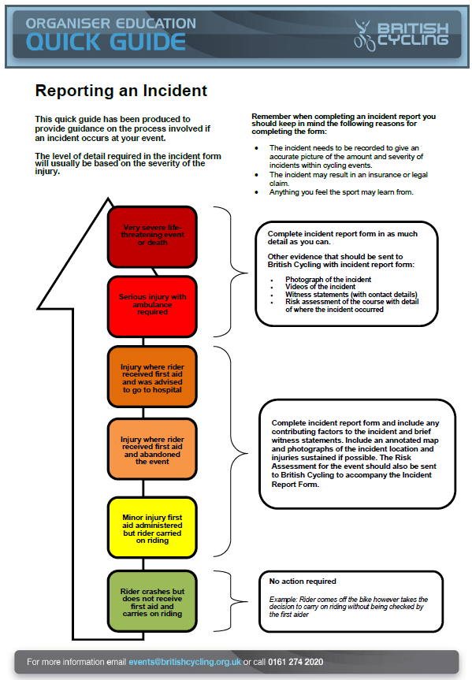

Event Organization Contact Numbers

Event Organizer- Chris Kettle- 07710631172

Event Day Registration and Second Contact- Julia Kettle- 07710631159

